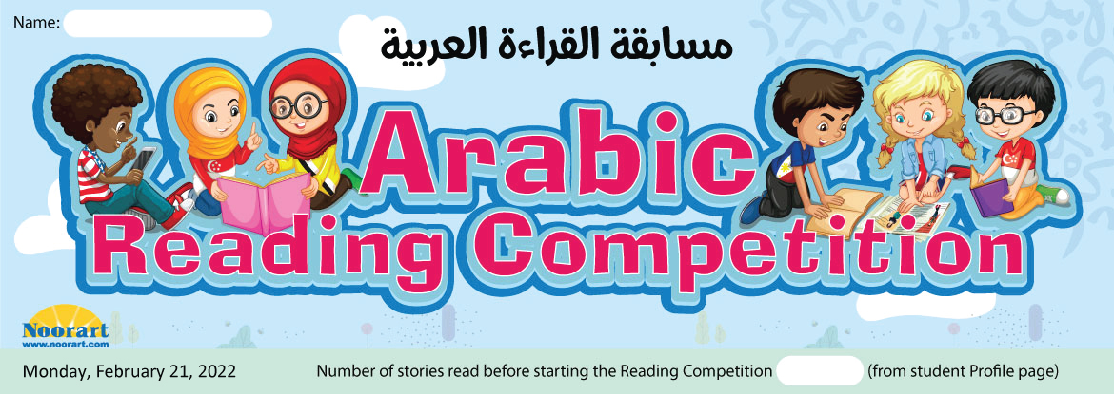
 | Date | My Daily Reading Log - Story Title | Stories read # | Student Notes
W  E  E  K  1 | Monday, February 21, 2022
 | Tuesday, February 22, 2022
 | Wednesday, February 23, 2022
 | Thursday, February 24, 2022
 | Friday, February 25, 2022
 | Saturday, February 26, 2022
 | Sunday, February 27, 2022
W  E  E  K  2 | Monday, February 28, 2022
 | Tuesday, March 1, 2022
 | Wednesday, March 2, 2022
 | Thursday, March 3, 2022
 | Friday, March 4, 2022
 | Saturday, March 5, 2022
 | Sunday, March 6, 2022
W  E  E  K  3 | Monday, March 7, 2022
 | Tuesday, March 8, 2022
 | Wednesday, March 9, 2022
 | Thursday, March 10, 2022
 | Friday, March 11, 2022
 | Saturday, March 12, 2022
 | Sunday, March 13, 2022
W  E  E  K  4 | Monday, March 14, 2022
 | Tuesday, March 15, 2022
 | Wednesday, March 16, 2022
 | Thursday, March 17, 2022
 | Friday, March 18, 2022
 | Saturday, March 19, 2022
 | Sunday, March 20, 2022
 |  | Total Number of Stories Read

